Worksheet 11.3

Read my lips
Student: Class:
The study of lip prints is called celioscopy. A person’s lip prints are unique. The use of lip prints in criminal cases is limited because the credibility of lip prints has not been firmly established in our courts.
The following is a case where the crime scene is a school bathroom. The crime is graffiti and the court is the principal’s office.
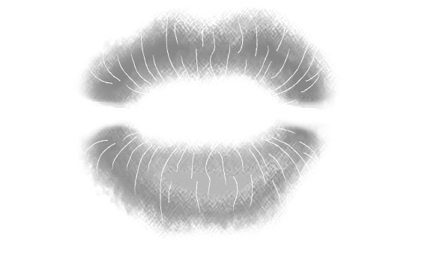
Lip print found on mirror
A student at the school has been writing graffiti in lipstick on the girls’ bathroom mirror. She has been signing her work with her lip print. The cleaner has to clean the mirror several times every day to remove the graffiti and is getting tired of this prank. The principal has each of the 5 suspects seen leaving the restroom make her lip print on a piece of card to compare to the lip print on the bathroom mirror. The girls are then taken to the bathroom where the cleaner shows how to clean off the lipstick by using the toilet brush!

Your task is to compare the lip prints of the 5 suspects to the lip print found in the bathroom and identify the culprit.
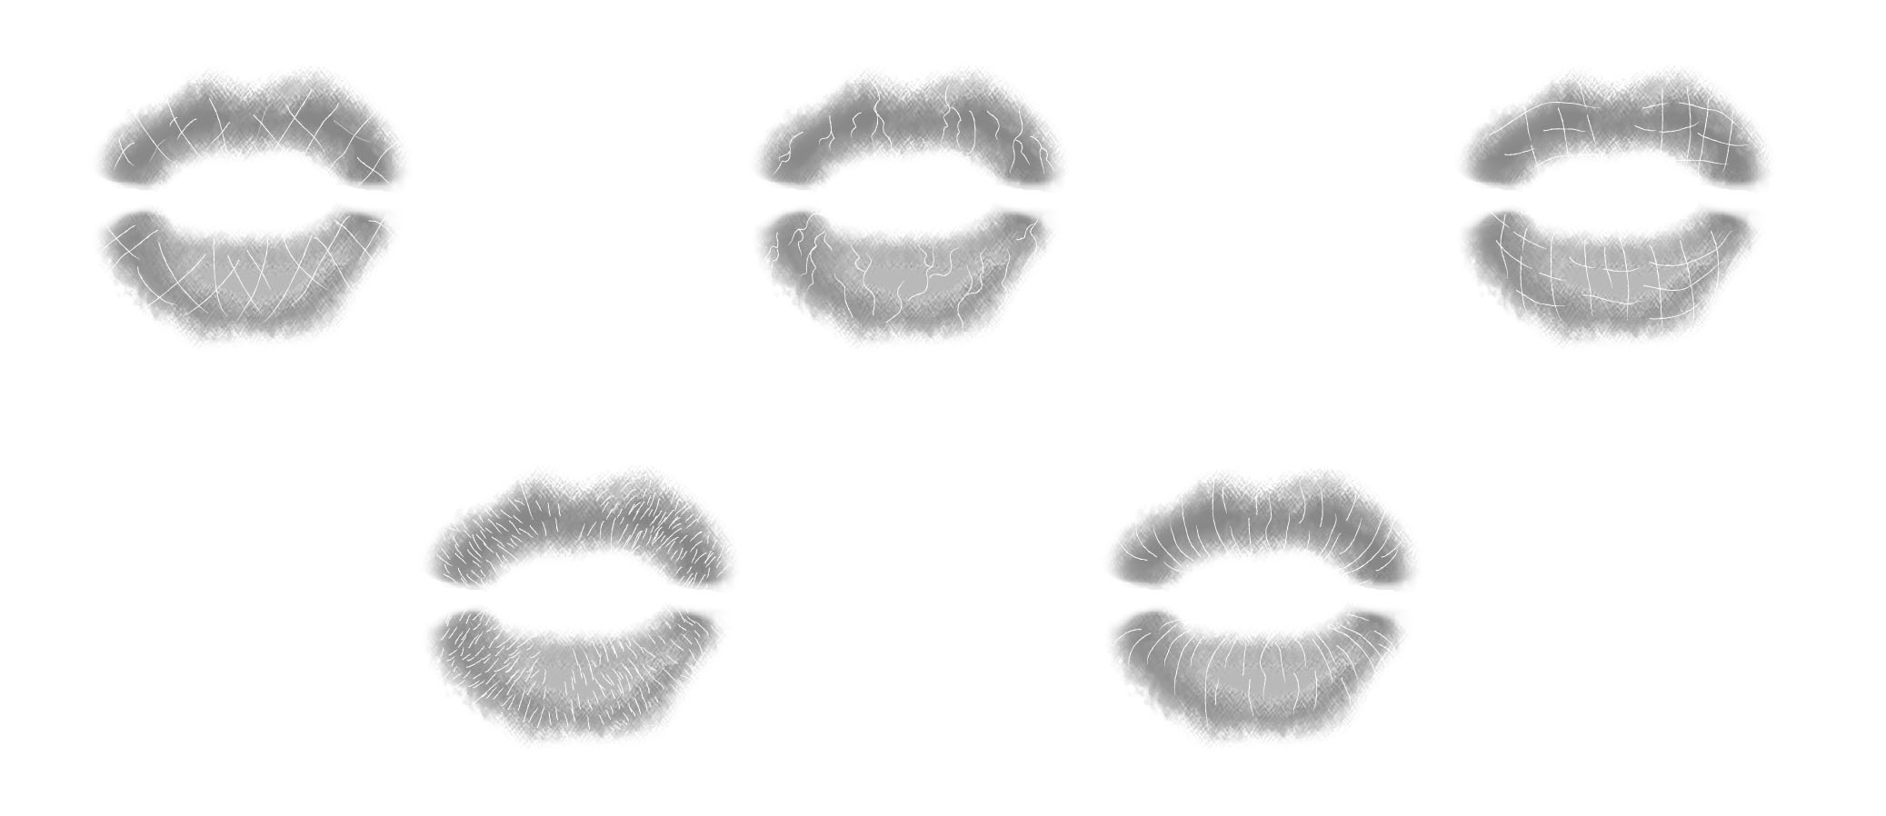
Branching grooves Suspect 2
Rectangular grooves Suspect 3
Long vertical grooves Suspect 5
Short vertical grooves Suspect 4
Diamond grooves Suspect 1

1. Look closely at each of the lip prints. Which lip print matches the crime scene lip print?

2. Do you think the use of lip prints is an effective method of identifying the perpetrator?

3. What other evidence could the suspect have left at the bathroom crime scene?

